1. Create a Ubuntu VM in <https://stack.cloud.hpc.ut.ee/> with size m1.xsmall
2. Installing xOpera orchestrator:
   * Connect to the vm and update the apt sudo apt update
   * Install the python virtual environment sudo apt install -y python3-venv python3-wheel python-wheel-common
   * Create a directory mkdir opera && cd opera, Download the opera wget <https://github.com/xlab-si/xopera-opera/archive/0.5.1.tar.gz> and untar it tar -xvf 0.5.1.tar.gz
   * Create a python virtual environment python3 -m venv .venv
   * activate it. .venv/bin/activate,Now you should see (.venv) $
   * Now change the dircd xopera-opera-0.5.1,
   * Install opera with required openstack libraries to use opera to connect openstack pip install -U opera[openstack] and sudo apt install python3-openstackclient
3. Download the OpenStack credentials. For this go to API *Access* -> *Download OpenStack RC file* -> *OpenStack RC file* (ldpc-openrc.sh).A sample screenshot is also given in the below figure

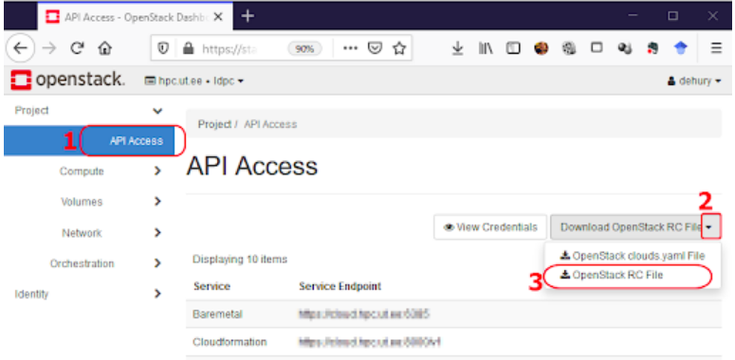

1. In linux terminal use the command to copy the file to vm: scp -i path-to-private-of-vm/yourkey-name.pem ldpc-openrc.sh username@your-ip:
2. Copy your open stack private key from your host machine to VM using gitbash in windows and in Ubuntu directly from the terminal. scp -i C:/Users/xxx/Desktop/xxx.pem C:/Users/xxx/Desktop/xxx.pem ubuntu@your-ip:
3. Add your ssh key to the SSH agent. First activate SSH agent service: eval `ssh-agent` then add the key ssh-add PATH_TO_YOUR_SSH_KEY.
4. Now run source ldpc-openrc.sh and it will ask for a password, please provide your openstack login password and test it using nova list to list all vms from openstack.
5. git clone <https://github.com/Afsana2910/webApp-loadbalancer-node_exporter-TOSCA>
6. Now move to project cd webApp-loadbalancer-node_exporter-TOSCA. Do ls -l, Now you should see the service template service.yaml.
7. Now to modify the following in nano service.yaml . Change the key_name and name in the load balancer and three vm.

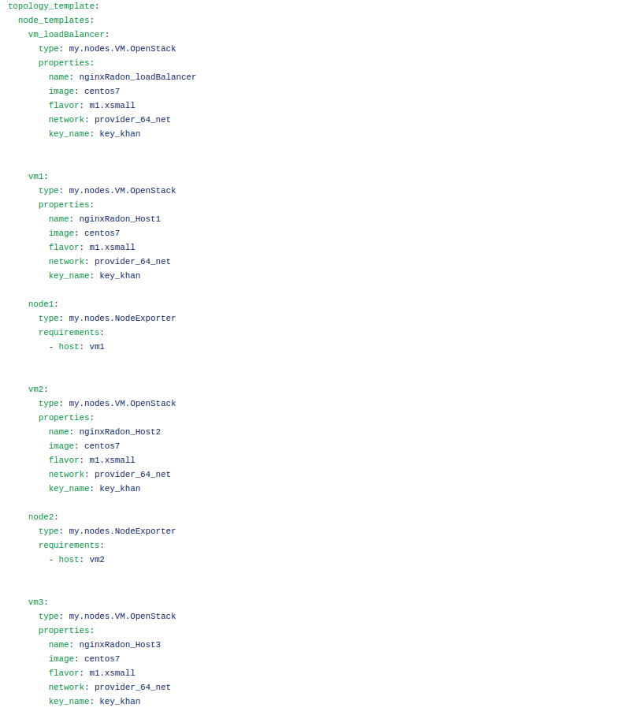

1. Run the command opera deploy service.yaml to deploy the service file
2. Run the command opera undeploy to undeploy.